Software Requirement Specifications
<Smart Beauty & Fashion Assistant>



Submitted by
Ayesha Ashraf (F22BINFT1M01030)

Submitted to
Dr Muhammad Asadullah

Department of Information Technology
Faculty of Computing
The Islamia University of Bahawalpur

Meeting Details
Sr No | Details | Date | Supervisor Signature
Summary
The Smart Beauty & Fashion Assistant is a web-based system developed to provide personalized beauty and fashion recommendations. The system collects user inputs—skin type, face shape, body type, preferences, weather, and occasion—to generate tailored suggestions for skincare, makeup, outfits, hairstyles, jewelry, and color suitability. This SRS document details all requirements, system features, user characteristics, technologies used, functional and non-functional requirements, and use cases necessary to fully understand and develop the proposed system.
The document summarizes the system’s purpose, scope, design approach, and expected outputs. It ensures clarity between the development team and stakeholders during system planning and implementation.

Table of Contents
1. Introduction 4
1.1. Purpose 4
1.2. Scope 4
1.3. Product Perspective 4
1.4. User Characteristics 4
1.5. Similar apps and systems/Literature Review 4
1.6. Proposed Technologies 4
2. Requirements 5
2.1. Function Requirements 5
2.1.1. Sign Up 5
2.2. Non-Functional Requirements 5
3. Use Cases and Flow of Processes 6
3.1. Use Case 1 7
4. References 8

- Introduction
The Smart Beauty & Fashion Assistant is an independent web-based system that provides personalized recommendations without depending on external commercial tools or brand-based promotion. It aims to function as an educational, brand-neutral digital styling assistant.
The system helps users make quick styling decisions and improves their understanding of beauty and fashion coordination. It collects information through a questionnaire and generates instant results using rule-based logic.

  - Purpose
The main goals of this project include: - To provide users with personalized beauty and fashion suggestions. - To help users choose skincare, makeup, outfits, hairstyles, and jewelry based on their features. - To offer color suitability suggestions using skin tone analysis. - To build a user-friendly system demonstrating final-year web development skills.

  - Scope

In Scope: - User Profile & Authentication (Register/Login) - Skincare recommendations - Makeup suggestions - Outfit recommendations - Hairstyle suggestions - Jewelry recommendations - Color suitability analysis (simple image-based tone detection) - Weather & occasion-based recommendations - Save favorite suggestions - Responsive web interface
Out of Scope: - No AI machine-learning-based predictions - No professional-grade image processing - No third-party brand promotions - No payment or e-commerce module

  - Product Perspective
This system will function as a stand-alone web application. The questionnaire module collects user inputs, the recommendation engine processes them, and the results page displays categorized suggestions.
Modules include: - User Profile - Input Questionnaire - Recommendation Engine - Color Suitability Module - Saved Looks
All modules integrate seamlessly to provide personalized suggestions.

  - User Characteristics
- General Users: Teens/Adults seeking beauty & fashion guidance.
- Students: Users learning basics of styling.
- Admins: Manage user accounts and system settings.
- Non-technical users: System must be easy and intuitive.

  - Similar apps and systems/Literature Review
Several platforms offer beauty advice but with limitations:
- StyleCraze – Provides general tips but lacks personalization.
- Maybelline Virtual Try-On – Focuses on makeup only.
- Sephora AI Stylist – Product-oriented, not brand-neutral.
Gap Identified: No simple, educational, fully personalized, brand-independent, web-based tool exists for basic styling and beauty help.
  - Proposed Technologies
- Frontend: HTML5, CSS3 / Tailwind CSS, JavaScript ES6+
- Backend: PHP or Node.js
- Database: MySQL
- Version Control: Git & GitHub
- Hosting: GitHub Pages / Simple PHP Hosting
- Image Handling: Basic skin tone color detection (client-side)

- Requirements
This section explains all functional and non-functional requirements needed for the complete system.
The system will:
- Collect user inputs through a questionnaire.
- Generate recommendations for skincare, makeup, outfit, hairstyle, jewelry, and suitable colors.
- Allow the user to save favorite looks.
- Maintain user profiles.
- Provide a responsive and mobile-friendly interface.
  - Function Requirements
Below are detailed functional requirements in standard SRS format.
    - Sign Up
- Name: FR001
- Purpose: Allow new users to create an account in the system.
- User(s): Admin, General Users
- Input:
  - Name
  - Email
  - Password(Must be 8 characters long and must include number)
  - Gender
  - Age
  - Skin Type
  - Body Type
  - Face Shape
- Output:User will be the member of system and able to login

    - User Login
- Name: FR002
- Purpose: Authenticate users to access personalized modules.
- Input: Email and Password
- Output:User is logged into the system.

    - Questionnaire Input Collection
- Name: FR003
- Purpose: To collect all styling-related inputs required for personalized results.
- Input: Skin type, body type, face shape, occasion, weather, preferences, and optional photo upload.
- Output: Inputs are submitted for processing.

    - Skincare Recommendation Engine
- Name: FR004
- Purpose: Suggest skincare routines based on skin type and concerns.
- Output: Basic steps such as cleanser, moisturizer, sunscreen recommendations.

    - Makeup Suggestion Module
- Name: FR005
- Purpose: Provide makeup tips suitable for user’s skin tone, occasion, and facial features.
- Output: Foundation shade tips, simple looks, color combinations.

    - Outfit Recommendation Module
- Name: FR006
- Purpose: Suggest clothing styles based on user’s body shape, preferences, and occasion.
- Output: Outfit styles, color combinations.

    - Hairstyle Suggestion Module
- Name: FR007
- Purpose: Suggest hairstyles based on user’s face shape.
- Output: Hairstyle names and tips.

    - Jewelry Recommendation Module
- Name: FR008
- Purpose: Suggest jewelry types that match the user’s face shape and outfit preferences.

    - Color Suitability Analysis
- Name: FR009
- Purpose: Analyze simple skin-tone colors from uploaded photo or user selection.
- Output: Recommended & avoid color palettes.

2.1.10.Save Looks
- Name: FR010
- Purpose: Allow users to save their favorite recommendations.
- Output: Saved in user profile.

2.1.11.View Saved Looks
- Name: FR011
- Purpose: Retrieve and display saved recommendations.

  - Non-Functional Requirements

NFR001 — Usability
The system must be easy to navigate with a clean UI.

NFR002 — Performance
All recommendations should load within 2–3 seconds.

NFR003 — Security
- Passwords must be stored using hashing.
- Input validation must prevent SQL injection.

NFR004 — Compatibility
System must work on mobile, tablet, and desktop.

NFR005 — Reliability
The system should have minimal downtime and handle multiple users.

- Use Cases and Flow of Processes
Below is the system-level use case for all main system functionalities
UC001 – User Registration
Actor: User
Description: User creates an account by entering name, email, and password.

UC002 – User Login
Actor: User
Description: Registered user logs in with email and password to access the system.

UC003 – Enter Skin & Beauty Details
Actor: User
Description: User provides skin type, tone, and beauty preferences for personalized suggestions.

UC004 – Skincare Recommendation
Actor: User
Description: System provides personalized skincare products and routine based on user details.

UC005 – Makeup Recommendation
Actor: User
Description: System suggests makeup shades and styles suitable for the user.

UC006 – Outfit Recommendation
Actor: User
Description: System recommends outfits based on occasion, weather, or preferences.

UC007 – Hairstyle Suggestions
Actor: User
Description: System suggests hairstyles according to face shape and hair type.

UC008 – Jewelry Recommendations
Actor: User
Description: System recommends jewelry matching the outfit and occasion.

UC009 – Save Favorite Looks
Actor: User
Description: User saves preferred looks or suggestions for future reference.

UC10 – Final Look Summary
Actor: User
Description: System combines skincare, makeup, outfit, hairstyle, and jewelry into a complete personalized look.

  - Use Case 1
ID | UC001
Name | Sign Up
Description | This use case describes how a new user registers an account in the system.
Requirement(s) | FR001
Actor(s) | Admin, User
Precondition | User must not already have an existing account.
Postcondition | Account is created and user can log in.
Basic Flow | Basic Flow  - Actor enter credentials  - System validates the inputs  - Following fields are required  - Name  - Email  - Password  - Address  - Phone  - Check the proper inputs for following  - Email  - Password must be 8 character including number  - Phone Number on 11 digits  - On successful validation the system will create new user  Alternative Flow  - Admin Sign In  - Create a new User by entering data  Exceptions  - Invalid Inputs  - System unable to response

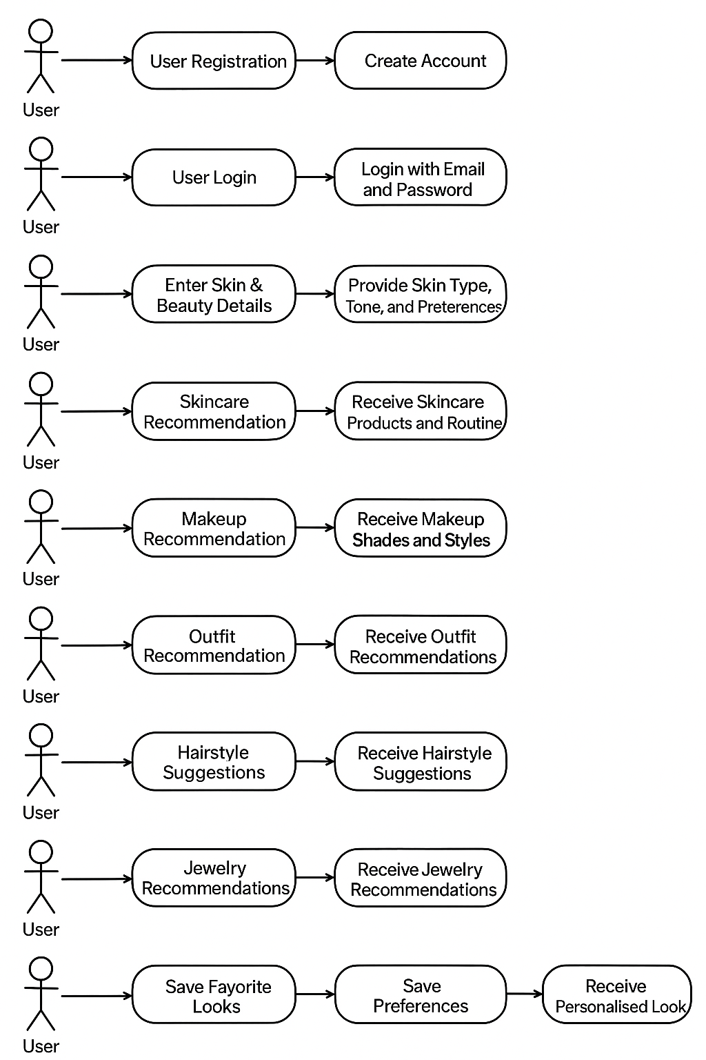

Diagram

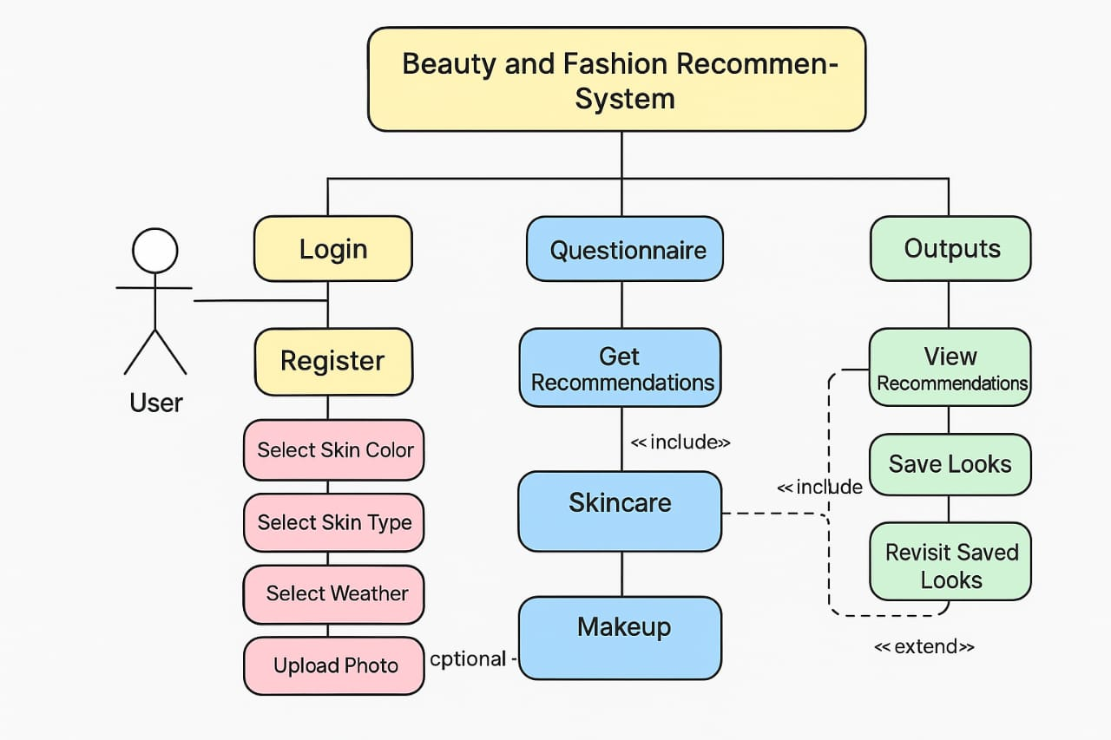
- References
1. W3Schools — HTML, CSS, JavaScript Tutorials
W3Schools, “HTML, CSS, JavaScript Tutorials.” [Online]. Available: [https://www.w3schools.com/](https://www.w3schools.com/).

2. MDN Web Docs — Web Development Reference
Mozilla Developer Network, “MDN Web Docs: Web Development Reference.” [Online]. Available: [https://developer.mozilla.org/](https://developer.mozilla.org/).

3. Tailwind CSS Documentation
Tailwind Labs, “Tailwind CSS Documentation.” [Online]. Available: [https://tailwindcss.com/docs](https://tailwindcss.com/docs).

4. PHP & MySQL Web Development (5th Edition)
L. Welling and L. Thomson, PHP and MySQL Web Development, 5th ed. Boston, MA, USA: Addison-Wesley, 2016.

5. IEEE Research Papers on Recommendation Systems
IEEE Xplore, “Research Papers on Recommendation Systems.” [Online]. Available: [https://ieeexplore.ieee.org/](https://ieeexplore.ieee.org/).

6. Sephora & Maybelline Virtual Try-On Tools
Sephora, “Virtual Artist – Try-On Beauty Tools.” [Online]. Available: [https://www.sephora.com/](https://www.sephora.com/).
Maybelline, “Virtual Try-On Tools.” [Online]. Available: [https://www.maybelline.com/](https://www.maybelline.com/).

